**Bootstrap 3 – First Exercise**

Bootstrap was developed by Mark Otto and Jacob Thornton at Twitter, and released as an open source product in August 2011 on GitHub.

**In June 2014 Bootstrap was the No.1 project on GitHub!**

**Why Use Bootstrap?**

Advantages of Bootstrap:

* **Easy to use:** Anybody with just basic knowledge of HTML and CSS can start using Bootstrap
* **Responsive features:** Bootstrap's responsive CSS adjusts to phones, tablets, and desktops
* **Mobile-first approach:** In Bootstrap 3, mobile-first styles are part of the core framework
* **Browser compatibility:** Bootstrap is compatible with all modern browsers (Chrome, Firefox, Internet Explorer, Edge, Safari, and Opera)

**Where to Get Bootstrap?**

There are two ways to start using Bootstrap on your own web site.

You can:

* Download Bootstrap from getbootstrap.com
* Include Bootstrap from a CDN

**Downloading Bootstrap**

If you want to download and host Bootstrap yourself, go to [getbootstrap.com](http://getbootstrap.com/getting-started/), and follow the instructions there.

## Bootstrap CDN

If you don't want to download and host Bootstrap yourself, you can include it from a CDN (Content Delivery Network).

MaxCDN provides CDN support for Bootstrap's CSS and JavaScript. You must also include jQuery:

### MaxCDN:

<!-- Latest compiled and minified CSS -->  
<link rel="stylesheet" href="https://maxcdn.bootstrapcdn.com/bootstrap/3.4.0/css/bootstrap.min.css">  
  
<!-- jQuery library -->  
<script src="https://ajax.googleapis.com/ajax/libs/jquery/3.4.1/jquery.min.js"></script>  
  
<!-- Latest compiled JavaScript -->  
<script src="https://maxcdn.bootstrapcdn.com/bootstrap/3.4.0/js/bootstrap.min.js"></script>

**One advantage of using the Bootstrap CDN:**

Many users already have downloaded Bootstrap from MaxCDN when visiting another site. As a result, it will be loaded from cache when they visit your site, which leads to faster loading time. Also, most CDN's will make sure that once a user requests a file from it, it will be served from the server closest to them, which also leads to faster loading time.

**jQuery**  
Bootstrap uses jQuery for JavaScript plugins (like modals, tooltips, etc). However, if you just use the CSS part of Bootstrap, you don't need jQuery.

## Create First Web Page With Bootstrap

**1. Add the HTML5 doctype**

Bootstrap uses HTML elements and CSS properties that require the HTML5 doctype.

Always include the HTML5 doctype at the beginning of the page, along with the lang attribute and the correct character set:

<!DOCTYPE html>  
<html lang="en">  
  <head>  
    <meta charset="utf-8">   
  </head>  
</html>

**2. Bootstrap 3 is mobile-first**

Bootstrap 3 is designed to be responsive to mobile devices. Mobile-first styles are part of the core framework.

To ensure proper rendering and touch zooming, add the following <meta> tag inside the <head> element:

<meta name="viewport" content="width=device-width, initial-scale=1">

The width=device-width part sets the width of the page to follow the screen-width of the device (which will vary depending on the device).

The initial-scale=1 part sets the initial zoom level when the page is first loaded by the browser.

**3. Containers**

Bootstrap also requires a containing element to wrap site contents.

There are two container classes to choose from:

1. The .container class provides a responsive **fixed width container**
2. The .container-fluid class provides a **full width container**, spanning the entire width of the viewport

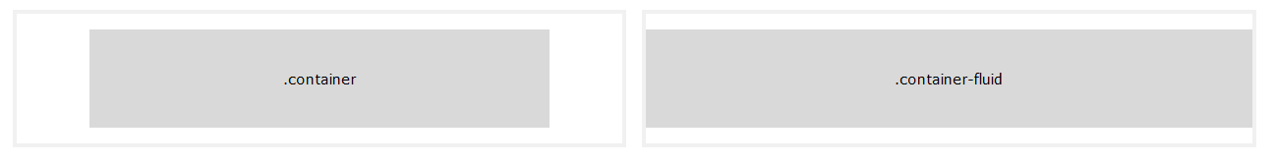

**Two Basic Bootstrap Pages**

The following example shows the code for a basic Bootstrap page (with a responsive fixed width container):

**Step 1:** Select, copy and paste this code

<!DOCTYPE html>  
<html lang="en">  
<head>  
  <title>Bootstrap Example</title>  
  <meta charset="utf-8">  
  <meta name="viewport" content="width=device-width, initial-scale=1">  
  <link rel="stylesheet" href="https://maxcdn.bootstrapcdn.com/bootstrap/3.4.0/css/bootstrap.min.css">  
  <script src="https://ajax.googleapis.com/ajax/libs/jquery/3.4.1/jquery.min.js"></script>  
  <script src="https://maxcdn.bootstrapcdn.com/bootstrap/3.4.0/js/bootstrap.min.js"></script>  
</head>

**Step 2:** Type the following code

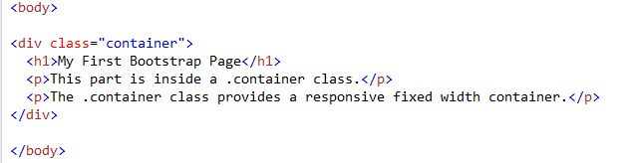

Your web browser should display:



**Step 3:** Edit your class to “container-fluid””

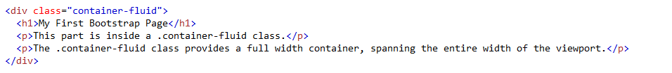

Your web browser should display:



**---------------------------------------------------------------------------------------------------------------------------------------------------------------**

**From your index portfolio webpage, using boot strap 3, create a greetingCard.html document, include the jumbotron and container section, this greeting card web page could be fictional, include an image your choice and text in the container, and link this page from your project.html page.**

**Using Snipping Tool, take screen shot of this greetingCard.html, copy/paste the web browser below:**

